# Introduction

The Finger Lift Switch was born from the request of Occupational Therapists working at SunnyHill Children’s Hospital in Vancouver British Columbia. The OTs were seeking an assistive switch capable of being operated by a very young child, who was unable to press down on conventional push button assistive switches. It was noticed that the child was able to lift some finger, albeit, with minimal force.

The intended users of the MMC Finger Lift Switch are people who experienced difficulties pressing downwards on conventional switches, but are able to lift fingers, even with minimal limited force.

# Research

While there appear to be no commercial switches that function via finger lifting action directly, there are low force switches that can be operated by a finger with low force.

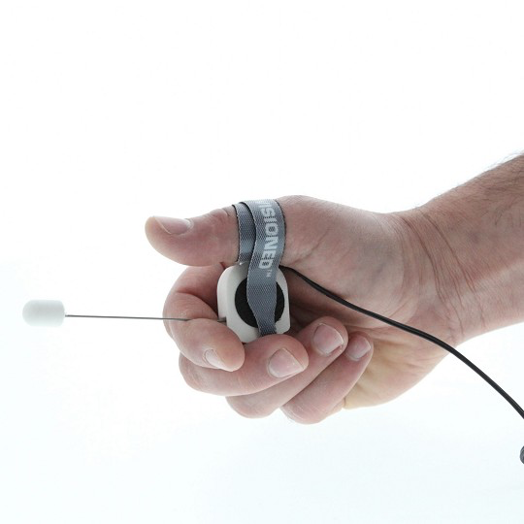

The “Wearable Finger Switch for Dexterity” sold by Rehab Mart. The Finger Switch by Enabling Devices. The Finger Switch was billed as “A wearable switch for persons with limited mobility. The slightest movement on the switch activates a device” The Finger Switch uses a small metal rod connected to a limit switch, with a 3.5 mm mono cable to trigger to any suitable device. The switch is constructed from a small 1 inch square by half inch injection molded case.

<https://www.rehabmart.com/product/finger-switch-32073.html>

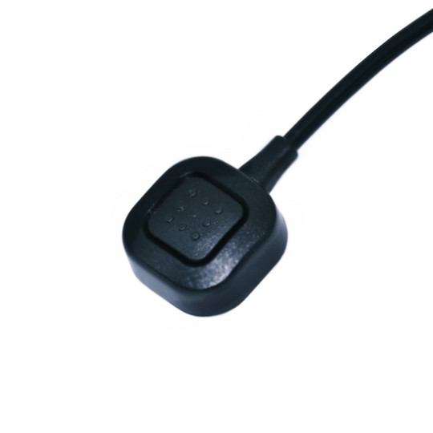

The “Adaptive Finger Switch” by GlassOuse

<https://glassouse.com/product-category/g-switch-series>

The Lift Switch by Stan Cassidy Centre for Rehabilitation (SCCR)

[http//www.stancassidy.ca](http/www.stancassidy.ca)

This is not an actual lift switch, but a switch output inverter, which makes the output state of the switch into its opposite. Note, that virtually all switch inverter circuits register as “on” when the user is not present, as their finger (or hand) is not resting on the switch to maintain the “off” state. This could be problematic in some situations.

# Requirements

## Goals

|  |  |
| --- | --- |
| G01 | An assistive switch that is activated by a finger lifting action. |
| G02 | To make the switch operate with minimal force, as in nearly unnoticeable to the user. |
| G03 | To make the switch operable in many different orientations i.e., minimally sensitive to gravity. |

## Functional Requirements

|  |  |
| --- | --- |
| F01 | The switch must activate when a finger lift is detected, but not when user’s hand is removed. |
| F02 | The switch must operate at angles from zero to at least 45 degrees from horizontal |
| F03 | The switch must be capable of activation with an operator force of less than 1 gram. |

## Non-functional Requirement

|  |  |
| --- | --- |
| NF01 | The switch should be narrow enough to allow at least 3 such switches to be operated by a user’s hand, though ideally, 5 (one for every finger). |
| NF02 | The switch must not require a battery. |

## Constraints

|  |  |
| --- | --- |
| C01 | The MMC Finger Lift Switch must be able to be constructed using basic ‘maker’ tools. |
| C02 | The MMC Finger Lift Switch should be able to be disinfected using detergent and alcohol. |

# Ideation

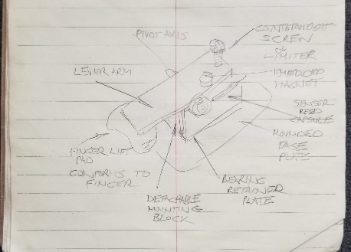

Early sketch based on discussion of requirements, with staff from Sunny Hill Children’s Hospital.

# Conceptual Design

## Concept 1

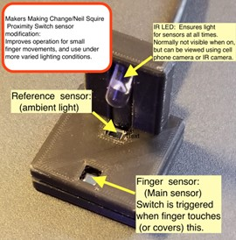

An initial electronic design of the Finger Lift Switch was created based on parameters given by the occupational therapist of the intended user. The original device was created using scraps of laser cut acrylic, nylon bushing, magnet, and a reed switch. The goal would be to create a final version using 3D printing methods.

## Concept 2

From a video of the user operating the initial optical design, it was determined the user had enough finger strength to operate a finger lever created based on a child’s ability to lift a finger 8 mm (as determined by occupational therapist of the intended user). The original reed switch version was created using scraps of laser cut acrylic, nylon bushing, and a reed switch. The goal would be to create a final version using 3D printing methods.

## Concept 3

## Photo of CurrentFinger Lift switch being adjustedSide view of current Finger Lift Switch with Finger pad on right.

## Prototyping

The first iteration was built quickly, using scrap laser cut plastic parts. It was never intended for long term use, but rather, confirming the method of operation would work for the intended recipient. With feedback from Sunny Hill staff, it became clear the switch was easy to operate for the user, but it would benefit from a longer lever arm and proper bearing, instead of a bushing. It also became clear that making a 3D printable version would be worth the effort.

The second iteration was also the first of the 3D printed versions of the Finger Lift switch. It had a longer lever arm, with an integrated finger pad. It only needed a single magnet to trigger the reed switch, as it still relied on a counterweight to return the lever to the default position.

The use of a bushing worked well in the first implementation and was close to being chosen as the main method of rotation. However, when the design was upscaled the design had issues with the lever sliding out of position on the bushing, so the design was changed to incorporate a bearing instead.

The final major design change was the addition of the magnetic lever return. This came about because the occupational therapist requesting the switch, wanted to try mounting the switch on a hand splint at an angle. When they did so, the counterweight no longer exerted the same degree of force on the lever arm, and the lever arm would become sluggish or end up getting stuck in position. With realization that the switch would be more versatile if orientation wasn’t an issue, the decision was made to change to some form of spring return. Using a pair of repelling magnets seemed like a natural fit, as one magnet was already needed for activation of the reed switch, and the magnets usually came in packages of 10 or more. What’s more, the “spring” repulsion force could be arbitrary, by adjusting the gap between the magnets. To top it all off, using two magnets turned out to be rather serendipitous, as the fixed repulsion magnet primed the reed switch, improving its sensitivity, and making switch return less “sticky”.

# Testing

# Photo of Finger Lift Switch reed switch plate being tested with a multimeter

# Detailed Design

# 3D model of Reed Switch Plate for Finger Lift Switch3D image of current Finger Lift Switch base

# 

During operation of the switch, it was noted that the lever arm finger pad sat lower than desired, making it awkward to initially place the user’s finger under the pad. A small post was added in the 3D CAD file to limit the lower end travel of the lever arm. With this change, there is always room under the finger pad to insert a finger prior to use.

# Design Review Improvements

Based on a group design review in July of 2022, several changes were made to the lift switch design. These changes were made for easier assembly, and less chance of breaking the delicate reed switch during construction. The changes made were:

* Widen base, reed switch plate, and solder area cups, to allow easier soldering of the reed switch.
* Remove requirement to bend reed switch wires (reed switch is very brittle glass), and instead, cut the reed switch wires using a jig to set the wire length.
* Trap the balance adjustment screw so it can’t fall out and become a choking hazard.

# Further Opportunities for Improvement

* Change 3D design to minimize number of different screw sizes needed.
* Optimize 3D design and printer placement to produce cleaner holes and minimize the need to trim off excess material i.e., hexagonal holes and increased clearances.
* Placing a screw in the lever arm to allow finger pad resting position to be adjustable.
* Make a version of the switch that uses a readily available paperclip as a bushing, instead of a more difficult to source bearing.
* Allow calibration of the reed switch/magnet gap to be done using a screwdriver, instead of loosening a plate, and repositioning.